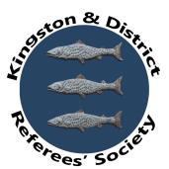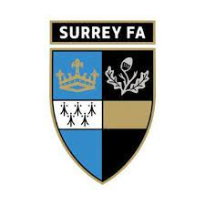

Kingston Referees’ Society in association with Surrey FA
New Referee Training
July-August 2021
Getting ready for the new season

Session 1. Wednesday 21st July. Preparation.

- Fitness training

- Pre-match warm-up
- Arriving at a venue
- Liaison with clubs
- Pre-match briefing
- Kit and equipment
- Looking the part
- Pitch inspection
- Player equipment inspection

Session 2. Wednesday 4th August. The game.

- Communication
- Signals
- Cautioning technique
- Positioning
- LOTG Update
- Offside

Session 3. Wednesday 18th August. End of the match.

- How to bring a game to a safe conclusion
- Dangers at the end of the game
- How to conduct oneself post-match
- Reporting results
- Reporting discipline.
- Observers
- Coaches

Sessions will start at 18.00, lasting a maximum of 90 minutes. All sessions will take place at Molesey FC, 412 Walton Rd, West Molesey, KT8 2JG. Car parking and refreshments available for spectators.
If you want to attend, please contact Philip Jones, Secretary at Kingston RA on philipjones54@btinternet.com. Tel: 07764612441

